**BRAINYBEE**

An Android Mobile Application Project presented to the

**Faculty of Information Technology**

School of Arts, Science, and Technology

The National Teachers College

629 J. Nepomuceno St., Quiapo Manila

By

Cadag, April Fiona B.

Ching, Ann Loraine S.

Coronado, Alynna Nicole R.

Evangelista, Aila Marie B.

Geralin, Jenevive D.

Glanida, Darla Ysabel B.

Laycano, Paul Justine S.

Morta, Angela Marie S.

Pollente, Immanuel George V.

In Partial Fulfillment of the

Requirements for the subject

Mobile Development focusing on Android Development

**2024**

**APPROVAL SHEET**

This Android mobile application entitled BRAINYBEE *were* prepared and submitted by:

Cadag, April Fiona B.

Ching, Ann Loraine S.

Coronado, Alynna Nicole R.

Evangelista, Aila Marie B.

Geralin, Jenevive D.

Glanida, Darla Ysabel B.

Laycano, Paul Justine S.

Morta, Angela Marie S.

Pollente, Immanuel George V.

has been approved by the subject adviser as partial fulfillment of the requirements for the subject **MOBILE DEVELOPMENT FOCUSING ON ANDROID DEVELOPMENT.**

**PROF. JOHN PAULO I. PERMINOLA**

Subject Adviser

**TABLE OF CONTENTS**

**Chapter I. PLANNING STAGE**

1.0 Introduction………………………………………………………………….

1.1 Objective of the Study…………………………………………………….

1.2 Scope and Limitation of the Study………………………………......

1.3 Significance of the Study………………………………………………….

1.4 Requirements Gathering………………………………………………..

1.5 Visual Table of Contents Diagram………………………………….

1.6 Definition of Terms……………………………………………………….

**Chapter II. UI / UX DESIGN**

2.0 Information Architecture……………………………………………..

2.1 Wireframes…………………………………………………………………..

2.2 Prototyping………………………………………………………………….

2.3 Mockups………………………………………………………………………

**Chapter III. DEVELOPMENT**

3.1 Mobile Architecture……………………………………………………….

3.2 Project Development……………………………………………………...

3.3 Project Builds………………….……………………………………………..

3.4 Pre-Testing process…………………………………………………………

**Chapter IV. TESTING AND QA**

4.1 User Manual………………………………………………………………….

4.2 Test Cases preparation……………………………………………………

4.3 Functional Testing…………………………………………………………

4.4 Usability Testing……………………………………………………………

4.5 Performance Testing……………………………………………………...

4.6 Device Testing………………………………………………………………

**Chapter V. LAUNCH AND DEPLOYMENT**

5.1 Finalized Build………………………………………………………………

5.2 Deployment…………………………………………………………………

**Chapter VI. MARKETING AND MAINTAINANCE**

6.1 Marketing Strategy………………………………………………..........

6.2 Updates and Fixes…………………………………………………………

**Appendices**

Appendix A: References…………………………………………………………………….

Appendix B: User Testing Survey Form.…………………………………………….

Appendix C: Accomplished Survey Forms …………………………………………

Appendix D: Recommendations…………….…………………………………………..

Appendix E: Gantt Chart……………………………………………………………………

Appendix F: Roadmap……………………………………………………………………….

Appendix G: Curriculum Vitae………………………………………………………….

Appendix H: Final Assessment…………………………………………………………..

**LIST OF FIGURES**

Figure #1 ( NAME) ………………………………………………………………………………………………

Figure #2 ( NAME) ………………………………………………………………………………………………

Figure #3 ( NAME) ………………………………………………………………………………………………

Figure #4 ( NAME) ………………………………………………………………………………………………

UNTIL THE LAST FIGURE

**LIST OF TABLES**

Table #1. (NAME OF TABLE)………………………………………………………………………

Table #2. (NAME OF TABLE)………………………………………………………………………

Table #3. (NAME OF TABLE)………………………………………………………………………

Table #4. (NAME OF TABLE)………………………………………………………………………

Table #5. (NAME OF TABLE)………………………………………………………………………

**CHAPTER I**

**THE PROBLEM AND ITS BACKGROUND**

**1.0 Introduction**

This research analyzes mobile development within the context of the Brainy Bee Learning App, a dedicated platform designed for children aged 2 to 5. As we enter the world of mobile application development, we want to know how strategic changes can improve the educational experience provided by Brainy Bee.

This study is aimed at examining the mobile development aspects that contribute to the app's functionality, usability, and overall impact on the learning journey of young minds. By analyzing the development process, we hope to uncover opportunities for improvement and innovation, ensuring that Brainy Bee remains at the forefront of engaging and effective educational tools.

Our goal as we navigate the complexities of mobile development for Brainy Bee is to not only improve the user experience for children and caregivers but also to contribute insights that can inform the broader conversation about educational technology. Join us as we investigate the symbiotic relationship between mobile development and early childhood education, with the goal of unlocking new levels of educational excellence within the Brainy Bee Learning App.

**1.1 Objective of the Mobile Application**

The objective of this application is:

* to create a platform that enables children to learn in a fun and interactive manner.
* to develop an application that offers a range of learning activities in different subjects.
* to improve children's cognitive abilities, foster creativity, and facilitate their academic growth.

to foster a sense of curiosity and exploration among children, motivating them to explore and pursue their interests within the educational framework.

**1.2 Scope and Limitation of the Mobile Application**

The application's scope is limited to kids aged 2-5 years old, specifically preschoolers, and their parents or guardians. The scope of this project is to develop an educational app that will primarily target foundational skills including basic numeracy, letter recognition, shapes, colors, and simple problem-solving. The scope of this statement is that interactive and visually engaging content is important for holding the attention of preschoolers. However, it does not provide any limitations or constraints on this statement. The scope of this study is to examine the importance of involving parents and guardians in the educational process for monitoring their children's learning activities. The limitation of this study is that it does not explore other factors that may influence children's learning outcomes. The scope of this initiative is to provide resources and support for parents in facilitating learning at home.

**1.3 Significance of the Study**

The study on mobile development within the context of the Brainy Bee Learning App is likely to benefit various stakeholders involved in early childhood education, educational technology, and child development. Here are the key beneficiaries:

**Children (Aged 2-5).** Children in the target age group are the study's primary beneficiaries. If it can improve the Brainy Bee Learning App, in any manner, this study can improve the educational experience for young learners by encouraging the development of cognitive skills, creativity, and foundational knowledge in an engaging and dynamic way.

**Parents and Guardians.** The study recognizes that parents and guardians play a crucial role in a child's education. Parents who are actively involved in their children's education would benefit if the results offer guidance on how to involve them and assist them in monitoring their kids' educational progress.

**Teachers and Curriculum Designers.** The study’s findings can be advantageous for educators and curriculum designers by providing a deeper understanding of how mobile applications, like the Brainy Bee Learning App, can align with early childhood learning objectives. This knowledge can inform the development of future educational content and activities.

**Mobile App Developers.** The study's conclusions can be helpful to developers who specialize in creating educational apps, particularly those aimed at young children. Finding areas where development strategies need to be improved can help developers create learning platforms that are more engaging and effective.

**Policy Makers in Education.** Those involved in shaping educational strategies and guidelines may find the study valuable. The outcomes could inform discussions on integrating technology into early childhood education and guide policy decisions related to the development and use of educational apps.

**Academic Community.** The academic community, including scholars, researchers, and educators in the fields of child development and educational technology, can find value in the study's contribution to the existing body of knowledge. It may inspire further research and discussions on optimizing mobile development for early childhood learning.

**1.4 Requirements Gathering**

Platform-specific requirements you will need.

* **Visual Studio Code.** for IDE
* **Figma.** for UI/UX Design Tool.
* **Java, JavaScript, and SQL.** for programming language, interactivity, and database
* **Gradle.** for Build System
* **JDK.** for Software Development Kit
* **Android Mobile Phone.** for build testing with specified Android version.

**1.5 Visual Table of Contents Diagram**

***Name of Module(Features)***

1.5.1 Sub features

1.5.2 Sub features

**1.6** **Definition of terms**

* Unfamiliar terms

**CHAPTER II**

**UI/ UX DESIGN**

This chapter indicates the interaction between users and digital products that focuses on the overall experience, usability, and accessibility of a user interface. To ensure that users can easily access and accomplish their goals by navigating and interacting with the user interface.

**2.0 Information Architecture**

* Diagram on how the information is processed from the database to the application and vice versa.

**2.1 Wireframes**

* Wireframes ( Figure # and name each frame) and its process and flow.

**2.2 Prototyping**

* Prototyping ( Figure # and name each frame) and its process and flow.

**2.3 Mockups**

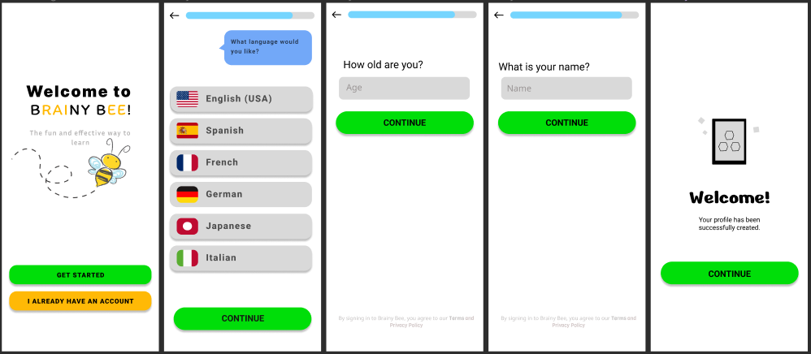

***Figure #1. Start-up Page***

The startup page plays a crucial role in creating the first impression and setting the tone for the entire user experience. This page shall be first accessed by the parents as there will be preference questions that a child may not yet understand, such as language preference, how old is their child, and the name of their child. Designing it with children in mind requires careful consideration of their cognitive abilities, interests, and visual preferences. Our team believes that the start-up page should be visually appealing with bright and cheerful colors to capture the attention of children, as well as a clean and modernized look to lessen user confusions. Thus our team came up with a clean and minimalistic design to achieve these goals.

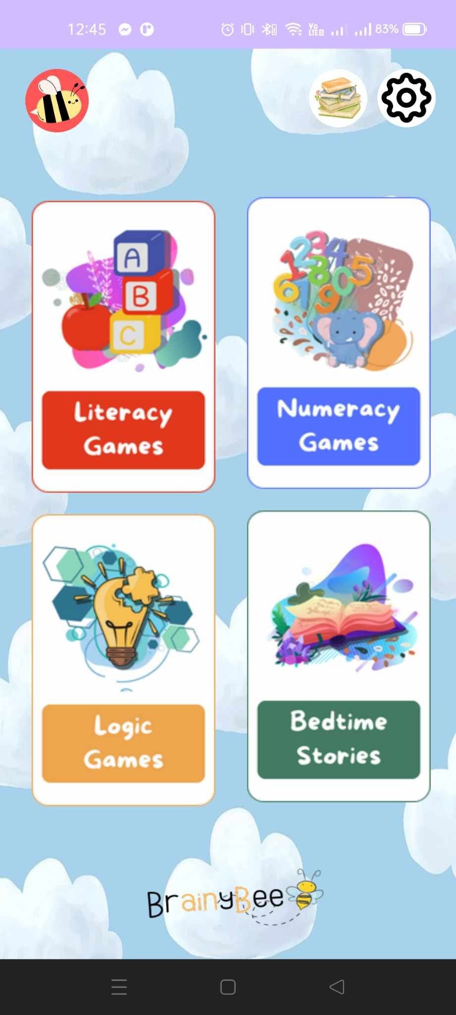

***Figure #2. Dashboard***

Users have the capability to traverse various activity modules within the dashboard, in addition to accessing account information, settings, and story libraries. This dashboard holds paramount significance within the gaming environment, serving as the focal point where key features are observed and navigated. Given that users allocate a substantial amount of time to this interface, the imperative for a meticulously crafted dashboard user interface becomes evident.

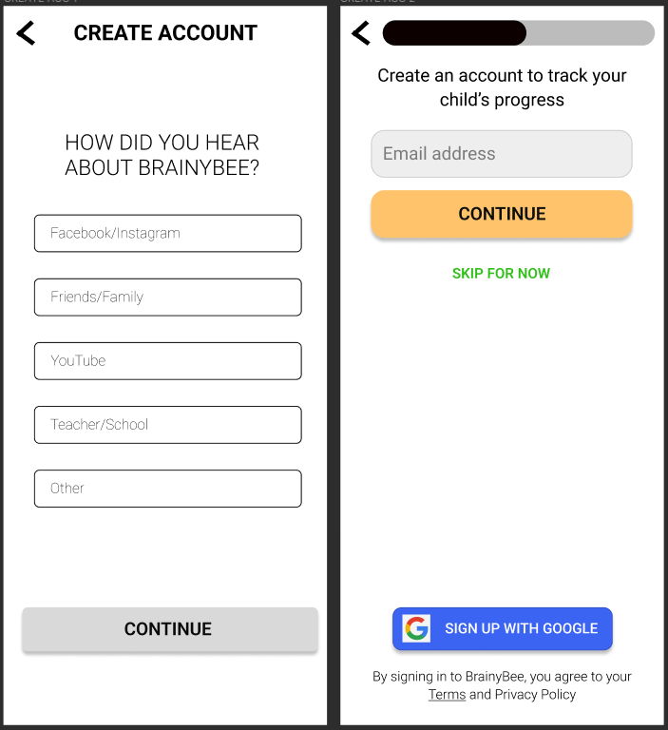

***Figure #3. Sign Up Page***

The "Create Account" page in a digital application is a critical component of the user onboarding process. This page serves as the gateway for users to establish a personalized account, enabling them to access features, save preferences, and enhance their overall experience within the application. Pages like, sign-up, login, and settings are all part of the parental features of the application.

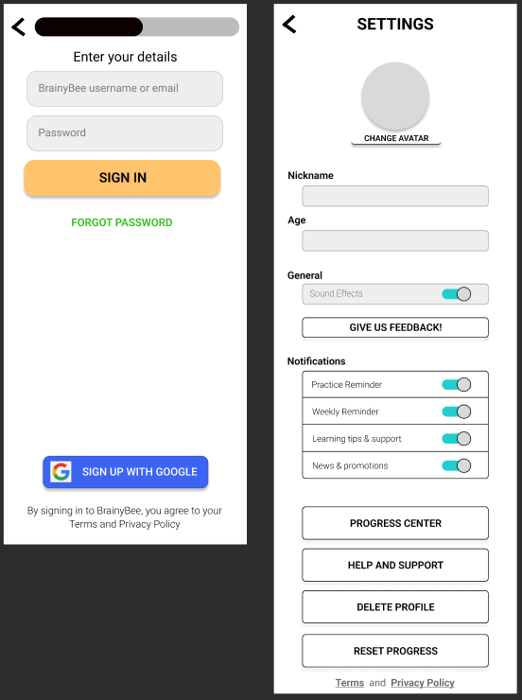

***Figure #4. Login Page to Settings***

The login page plays a vital role in every digital application, serving as the initial access point for users who have previously established an account. The page's design and functionality are crucial factors in ensuring a user experience that is both smooth and secure. This feature will allow users to access tools that are not accessible for those who signed up as guests. If users are new to the apps, after signing up, they will be redirected to the Login page and then to settings for additional customization.

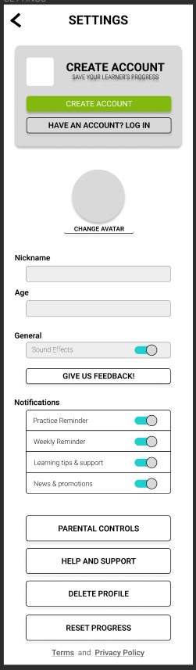

***Figure #5. Settings***

Settings pages in digital applications provide users with the ability to customize their experience, manage preferences, and control various aspects of the application. These pages are essential for tailoring the app to individual needs and ensuring a personalized and user-friendly experience. Users can manage and update their account information, including profile pictures, usernames, and email addresses. Options to change passwords or update security settings for enhanced account protection. They also have the ability to choose preferred language and regional settings to customize the app's content and language of communication. Users may also access information about the app, such as version number, terms of service, and links to support or help resources. Moreover, there will be a section where users can provide feedback, report issues, or make suggestions for improvement.

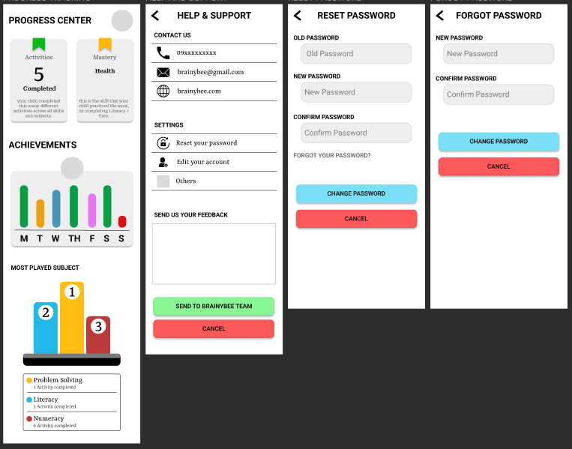

***Figure #5.1. Settings Sub-Features***

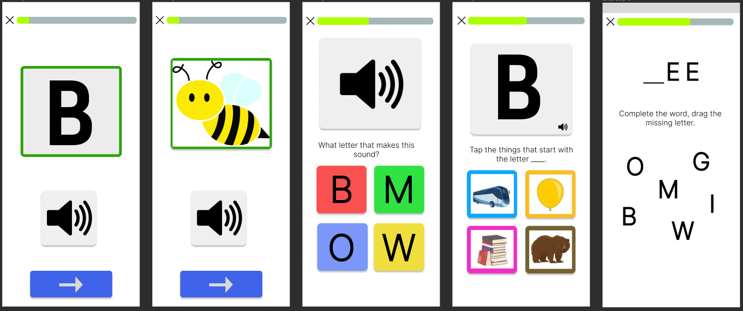

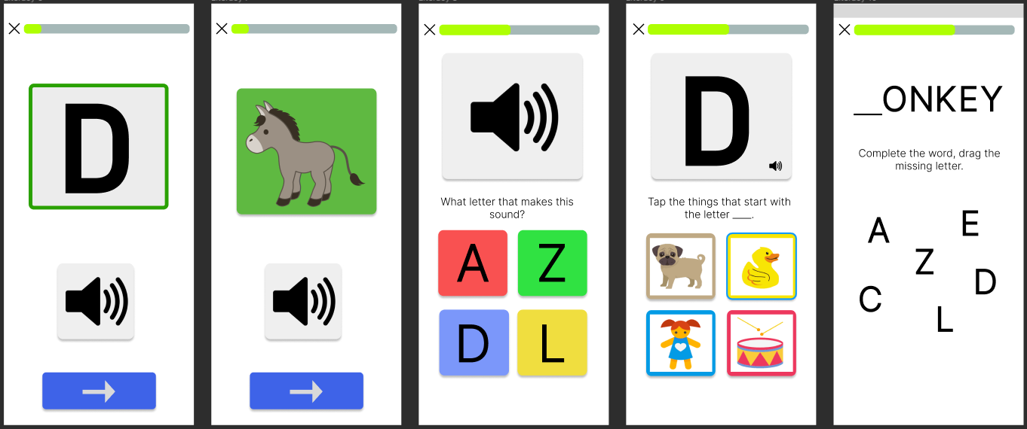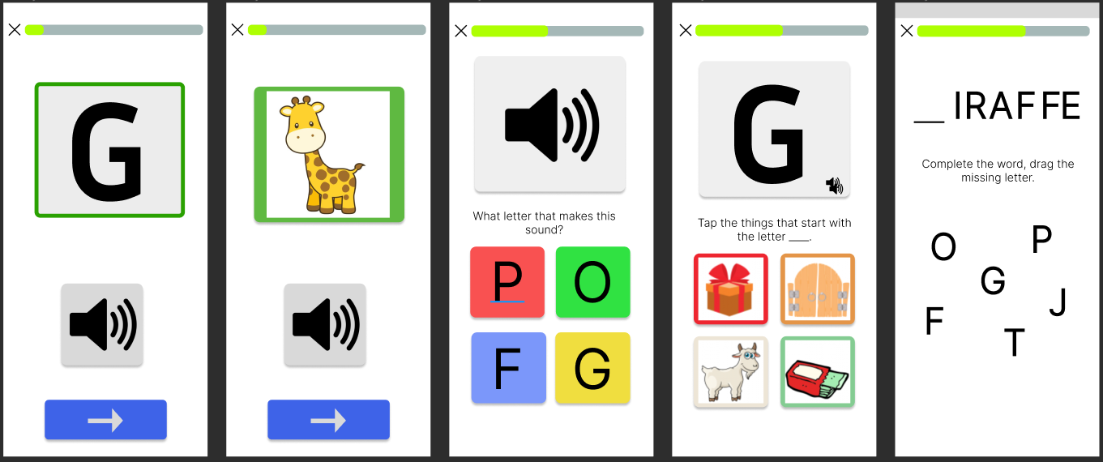

***Figure #6. Literacy Module Games***

A literacy game is an interactive and engaging educational tool designed to enhance and reinforce literacy skills in users, especially children. These games are crafted with the intention of making the learning process enjoyable, fostering a positive attitude towards reading, writing, and language development. The game revolves around activities that are focused on phonics, helping young learners with letter-sound associations and pronunciation through interactive games and exercises. All games are incorporated with a progress tracking system that allows players and, if applicable, parents or educators to monitor the user's advancements and identify areas for improvement.

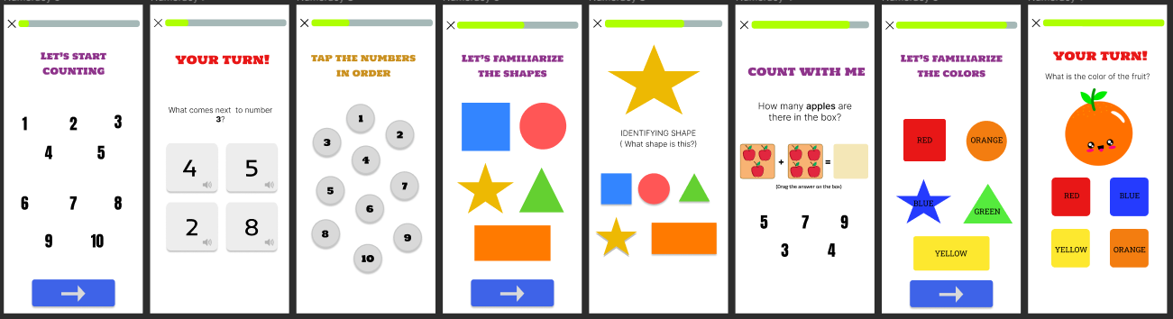

***Figure #7. Numeracy Module Games***

Numeracy games are interactive and educational activities designed to enhance numerical skills and mathematical proficiency in players, particularly children. These games make learning math enjoyable and engaging, fostering a positive attitude toward numbers and problem-solving. The game is built around a compelling theme, integrating mathematical concepts seamlessly into the gameplay to make learning enjoyable and immersive. The games are designed to help players recognize and understand numbers, including numeral identification, counting exercises, and ordering sequences.

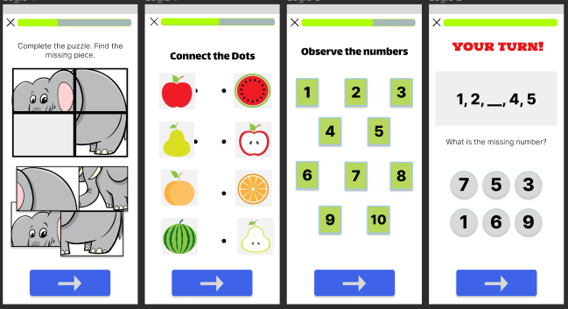

***Figure #8. Puzzle Games***

Logic games are interactive and intellectually stimulating activities that challenge players to solve problems, exercise their cognitive abilities, and think critically. These games come in various formats, from traditional jigsaw puzzles to digital applications that incorporate innovative challenges. These games are puzzles and games that promote logical reasoning and critical thinking, encouraging players to use mathematical principles to solve problems.

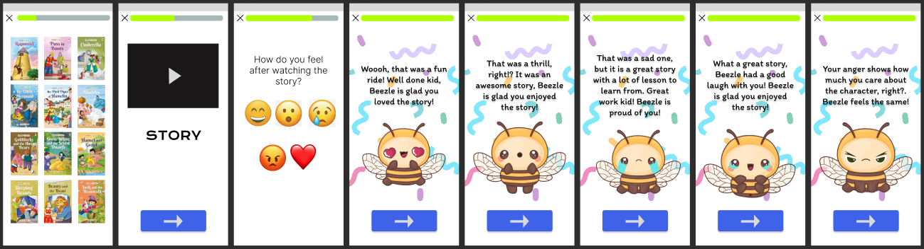

***Figure #9. Story Module***

A story module refers to a component within a digital application or platform that focuses on the creation, presentation, or interaction with narrative content. This module is designed to facilitate storytelling, whether it's in the form of user-generated content, interactive storytelling experiences, or curated narratives. It supports various media formats, such as images, videos, audio, and animations, to enhance the storytelling experience and allow for multimedia-rich content. This feature also incorporates socio-emotional learning by asking learners what they felt after reading/watching the story.

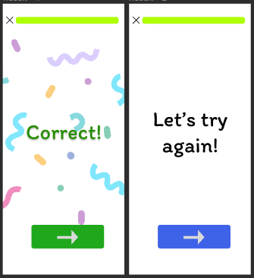

***Figure #10. Result Page***

A result page is a screen or interface that displays outcomes, findings, or information based on user input or a specific query. This page will be the basis of the child's learning progress.



***Figure #11. Credit Page***

The credit page serves as a rewarding culmination and acknowledgment for the child user's dedication and effort upon completing the entire module. It stands as a virtual trophy, providing a tangible validation of their accomplishments and a token of recognition for the hard work and commitment they invested in the learning experience.

This celebratory page is not only a testament to the child's achievements but also an opportunity to reinforce positive behavior and encourage continued engagement. By displaying the credit page upon module completion, the application not only acknowledges the child's success but also reinforces the value of perseverance and commitment to learning.

In addition to recognizing the child's efforts, the credit page includes encouraging messages, and colorful visuals to enhance the sense of achievement. This positive reinforcement contributes to fostering a sense of accomplishment and self-confidence in the child, making the learning process not only educational but also enjoyable and emotionally rewarding.

Moreover, the credit page can serve as a platform for parental or guardian involvement by providing them with insights into their child's progress. This transparency can encourage a supportive environment where caregivers actively participate in and celebrate the child's learning journey.

**CHAPTER III**

**DEVELOPMENT**

In this chapter, the development of the application is being tracked. The mobile architecture is elaborated, and further diagrams along with discussions on important source codes are presented.

**3.1 Mobile Architecture**

- Pano naimplement yung UI nyo then , Workflow ng bawat structure at data.

**3.2 Project Development**

**-** Coding Process

**3.3 Project Builds**

- Run every build discuss the progress

**3.4 Pre-Testing process**

**-** Set testing procedures

**Chapter IV TESTING AND QA**

4.1 User Manual

4.2 Test Cases preparation

4.3 Functional Testing

4.4 Usability Testing

4.5 Performance Testing

4.6 Device Testing

**Chapter V. LAUNCH AND DEPLOYMENT**

5.1 Finalized Build

5.2 Deployment

**Chapter VI. MARKETING AND MAINTAINANCE**

6.1 Marketing Strategy

6.2 Updates and Fixes

**APPENDIX A**

**REFERENCES**

**APPENDIX B**

**USER TESTING SURVEY FORM**

**APPENDIX C**

**ACCOMPLISHED SURVEY FORMS**

**APPENDIX D**

**RECOMMENDATIONS**

**APPENDIX E**

**GANTT CHART**

**APPENDIX F**

**ROADMAP**

**APPENDIX G**

**CURRICULUM VITAE**

**APPENDIX H**

**FINAL ASSESSMENT**